*The Hack architecture partitions the address space and does not allow both data and instructions to be stored in the same space. What are the implications of this architecture? Explain and discuss in your own words.*

The separation of data and instruction memory areas means that instruction memory can be said as read-only memory (ROM) that stores instructions information, while data memory can be called as random access memory (RAM) that stores ordinary data information. In the Hack architecture, the instruction information in ROM is preburned, which requires to replace entire ROM to execute different instructions as it is impossible to overwrite existing instructions on it. As a basic example of ROM usage, the idea of BIOS came up to my mind first. Since BIOS is a basic software to call bootloader to execute operating system of computer, the instructions have to be predefined. I mean every time computer is booted, the same instructions must be executed and those should not be changed. This is the very same thing as how ROM works written above. Based on this BIOS example, an implication from the difference of data and instruction memory is that the instructions data that must be done in all the same way repeatedly are stored in ROM, while temporary data that points to the address information of registers.

*Discuss the difference between RISC and CISC architecture. What are the advantages and disadvantages of each architecture?*

Let me begin with the definition of each word. RISC stands for “Reduce Instruction Set Computer”, while CISC stands for “Complex Instruction Set Computer”. As the name of each shows CISC treats complex instructions while RISC intentionally treats only simple instructions. There are some points that make the difference between these two. The biggest difference is their hardware architecture. As CISC accesses directly to main memory, while RISC uses two type of cache memory, instruction and data cache. As we have seen, this separation of memory cache by RISC is true to the architecture of Hack computer. While CISC has realized a specialized function of computing, which is equal to complex, it is difficult to maintain a simplicity of hardware and software architecture to embrace those complexity. On the contrary, RISC has made it possible to realize higher performance because of simple instructions. As the chip treats only simple instruction set, spaces to store extra functions such as floating number calculations were born. This is a historical background of why RISC has been a more common hardware architecture of processors.

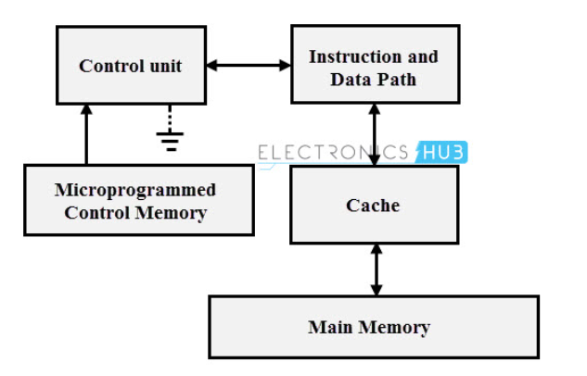

CISC hardware architecture from RISC Vs CISC (2015)

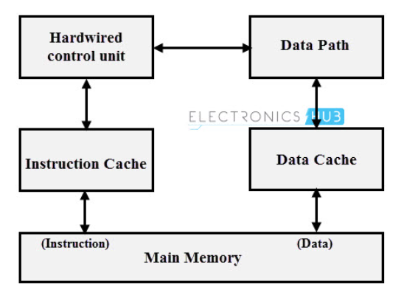

RISC hardware architecture from RISC Vs CISC (2015)

**References:**

RISC Explained – Everything You Need To Know (2021). *History Computer.* Retrieved July 21, 2022, from <https://history-computer.com/risc-explained-everything-you-need-to-know/>

RISC Vs CISC (2015). *Electronics Hub.* Retrieved July 21, 2022, from <https://www.electronicshub.org/risc-and-cisc-architectures/#:~:text=RISC%20processors%20can%20be%20designed,as%20compared%20to%20CISC%20processors>.